WORDSNAKE EXERCISE

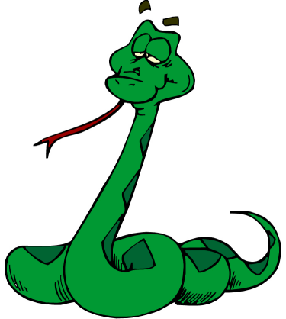

Retype the following text inserting the spaces where appropriate

Lady Gaga - Early life and education
Born on March 28, 1986, in Yonkers, New York, the eldest child of Italian American parents Joseph and Cynthia Germanotta, at age 11 she was set to join Juilliard School in Manhattan, but instead attended Convent of the Sacred Heart, a private Roman Catholic school. Playing piano by ear from the age of 4, she went on to write her first piano ballad at 13 and began performing at open mike nights by age 14. At age 17, she gained early admission to the New York University's Tisch School of the Arts. There, she studied music and improved her song writing skills by composing essays and analytical papers focusing on topics such as art, religion and socio-political order. She later withdrew from the school to focus on her musical career.

